Problems with Friction

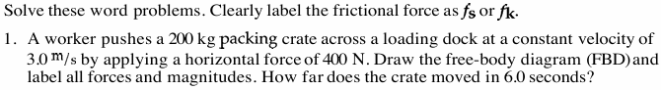

\

Friction Conceptual Development
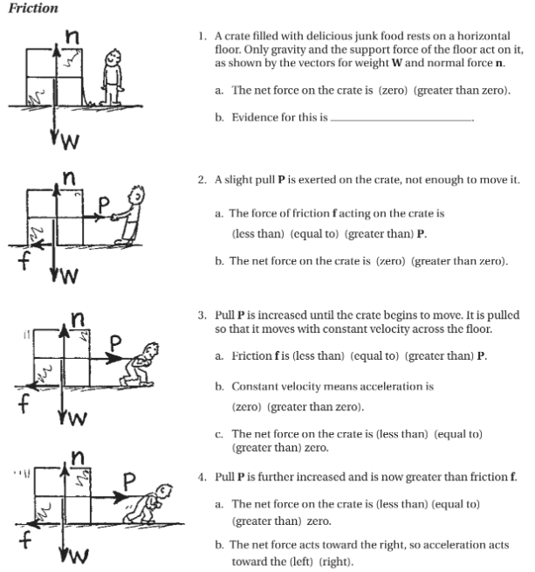
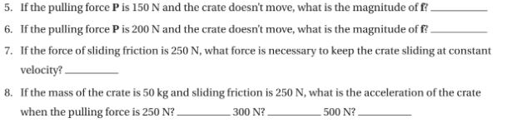

Dynamic Problems with Friction

